[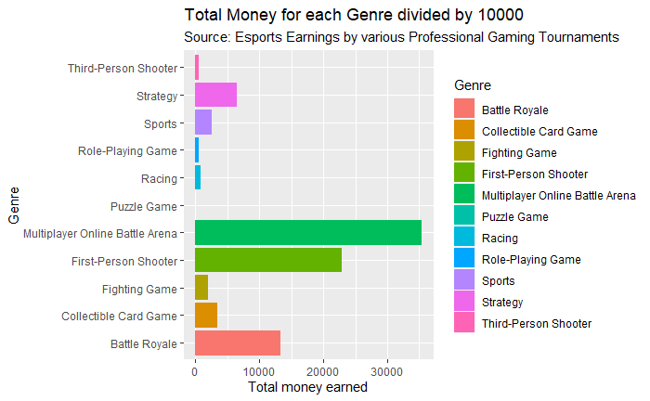](https://user-images.githubusercontent.com/58013489/104498633-f6009780-55a9-11eb-9162-2f811da30843.png)

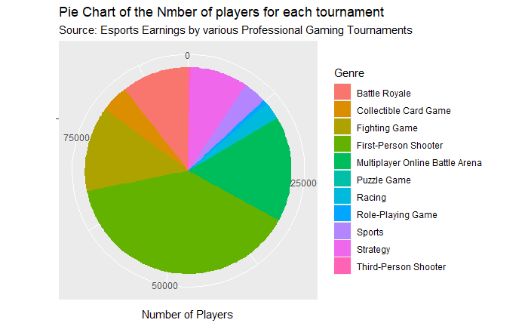

[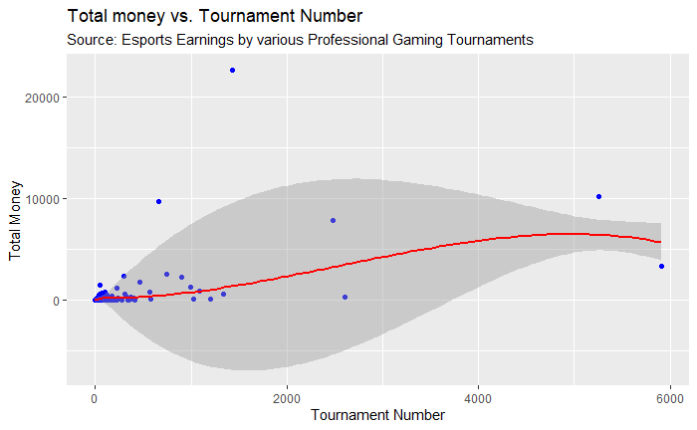](https://user-images.githubusercontent.com/58013489/104499241-d0c05900-55aa-11eb-8993-0389944aa0b6.png)

